**nMOS Characteristics**

Aim: to find **gm, ro, gmb** and current **Id** in virtuoso ADE-explorer.

Technology Node: **45nm**.

Schematic Diagram:

1. **For gm: we now gm = change in id with respect to vgs = d(id)/d(vgs)**

We choose drain pin to calculate id current and sweep input voltage means vgs from 0 to 1.8 volt.

Result of id vs Vgs plot:

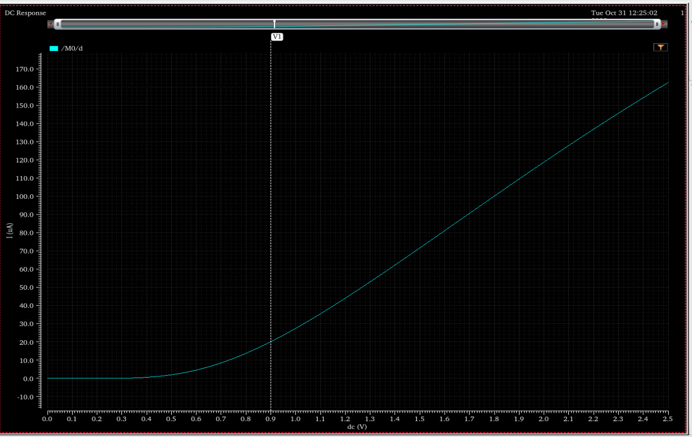

Now we get id/vgs graph, but our aim is to find transconductance means gm which is derivative of id/vgs.

By using of calculator, we can find of derivative of output wave:

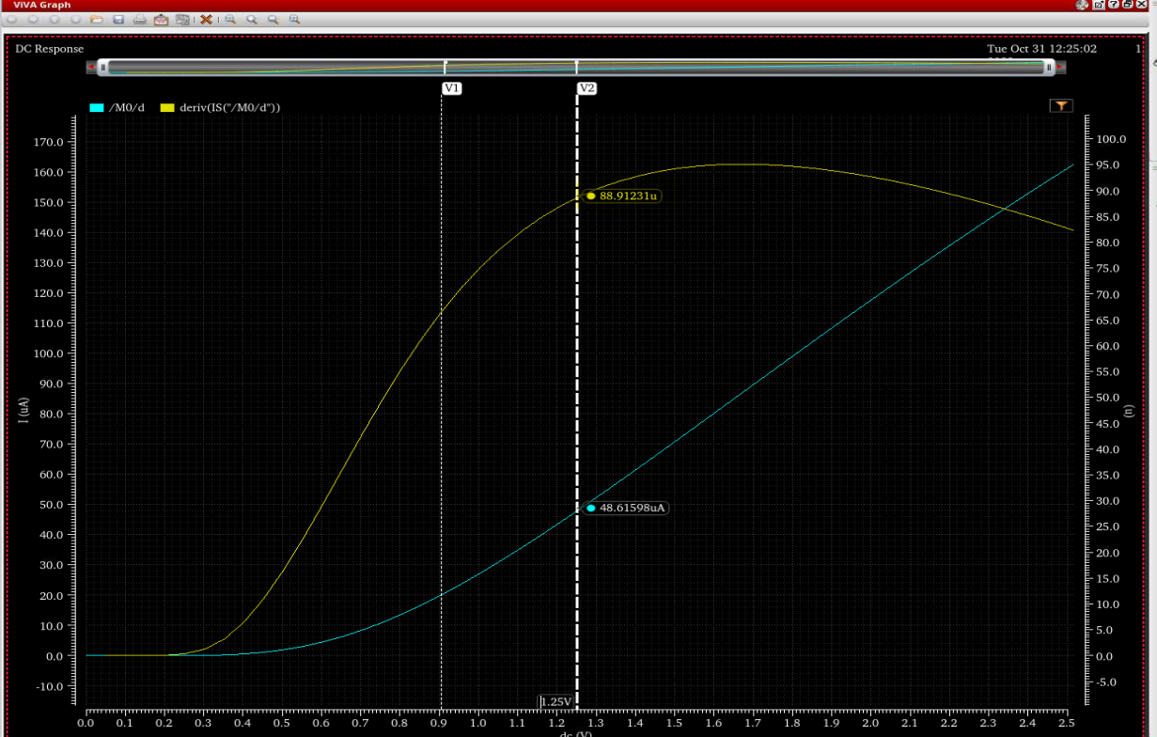

we can see on graph gm = 89.9124 u

1. **For ro calculation = d(vds)/d(id)**

We select vds this time and for id we can go with same as previous.

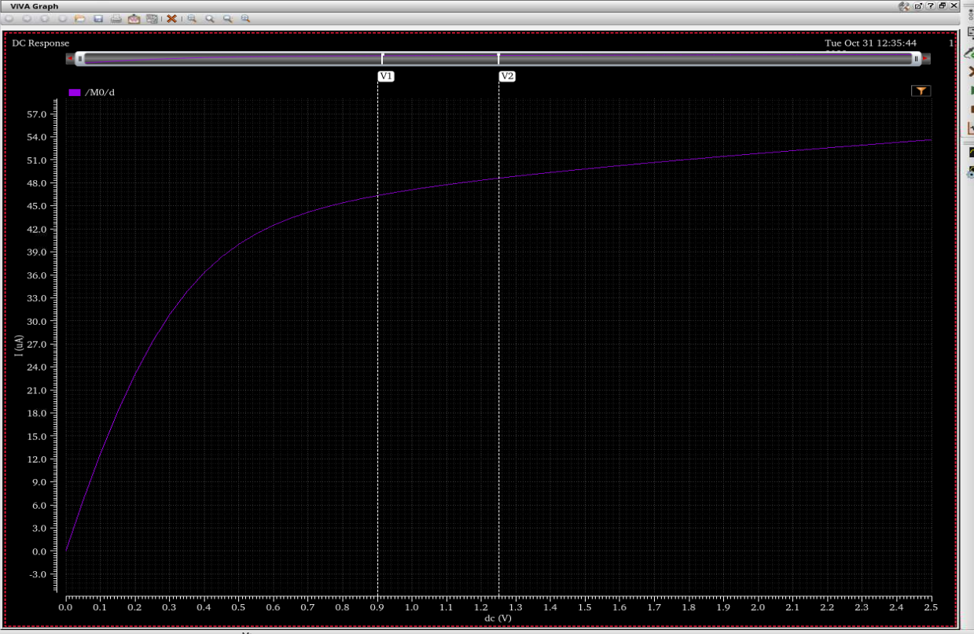

The above graph is id/vds but we know for ro we have to find its reciprocal and derivative . we can achieve this by using calculator.

Output graph of d(id)/d(vds) is:

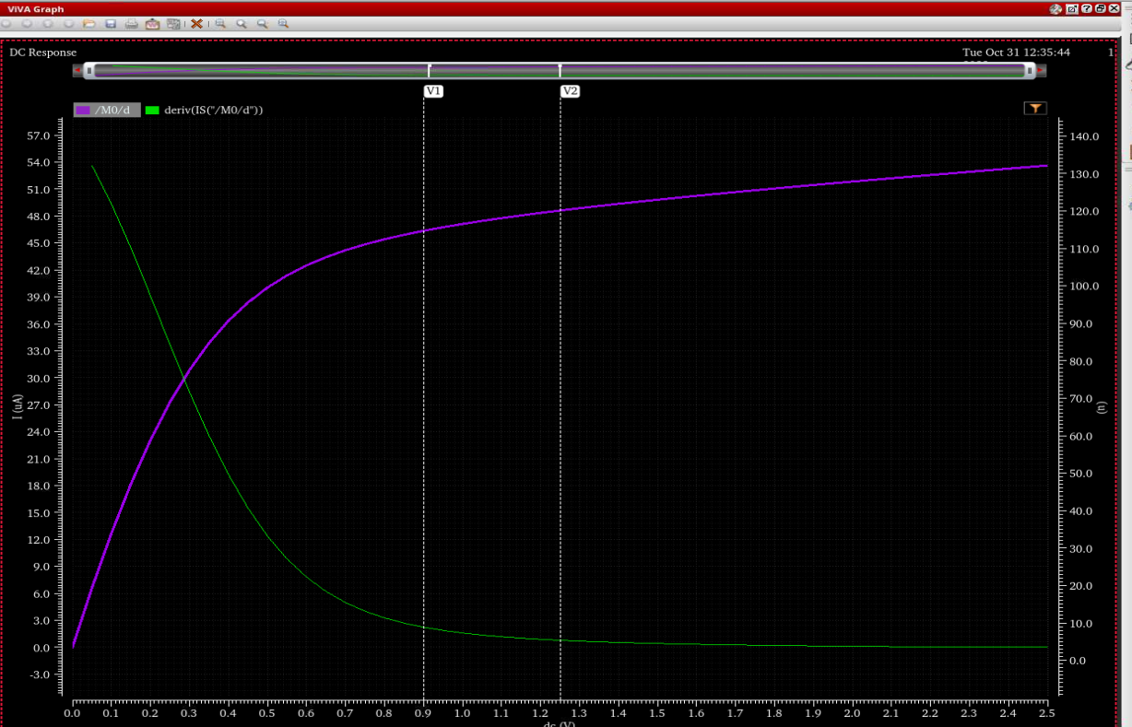

Now we have to find reciprocal of d(id)/d(vds):

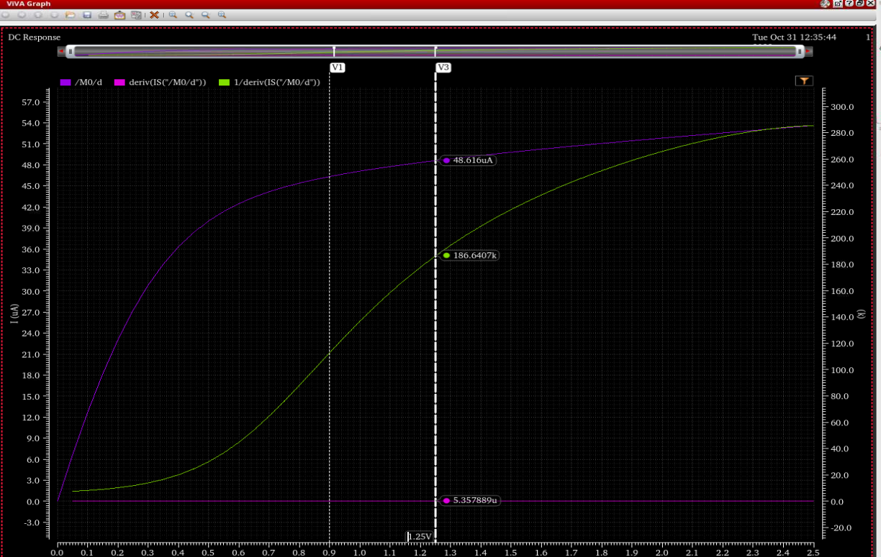

ro = 186.640k

1. **Calculate gmb**

We know that gmb = d(id)/d(vbs)

Output graph of d(id)/d(vbs) :

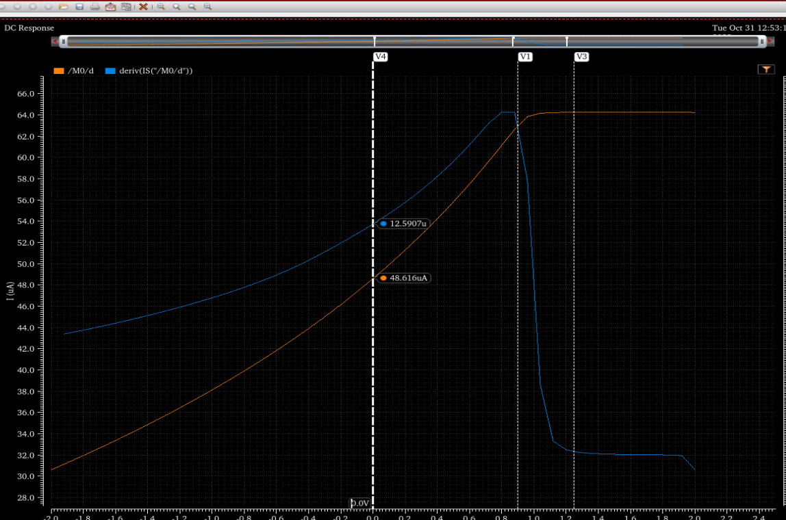

Gmb =12.5097u